PICTURES OF JOINT INVESTIGATION VISIT TO OANDO ENERGY RESOURCES LIMITED FACILITY AT 18” TEBIDABA/BRASS PIPELINE, LAGOSGBENE, SILGA BAYELSA STATE ON 24TH SEPTEMBER, 2024.
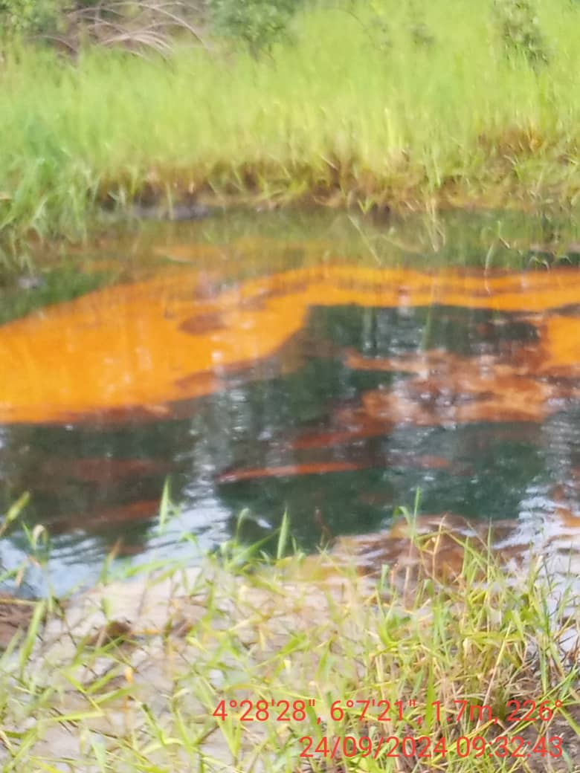
FIG. 1: THE STATE OF THE ENVIRONMENT BEFORE EXCAVATION.
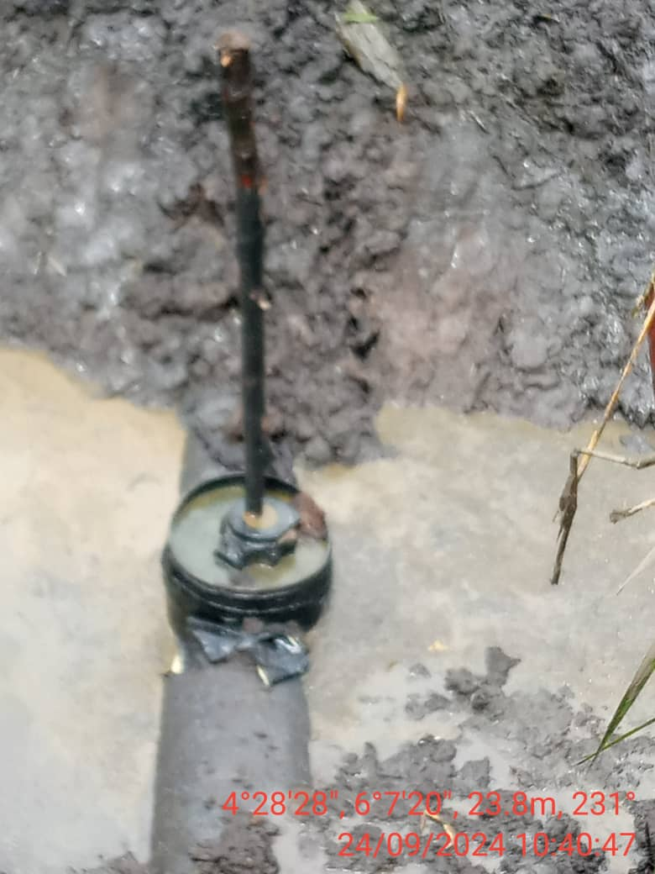
FIG. 2: 3” VALVE INSTALLED AT 12 O’ CLOCK POSITION.

